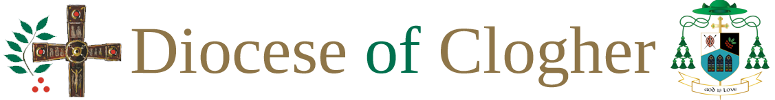
Support Services
Towards Healing
Towards Healing is an independent organisation providing professional support for people who have experienced institutional, clerical or religious abuse in Ireland www.towardshealing.ie
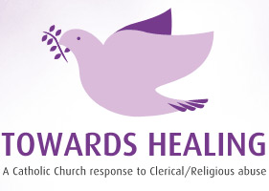
Towards Peace
Towards Peace offers spiritual support for survivors of abuse by Catholic Church personnel in Ireland. The vision of Towards Peace is to provide a safe supportive space, where people who have been affected by abuse in a Church context can be accompanied as they seek their own experience of spiritual peace. www.towardspeace.ie

