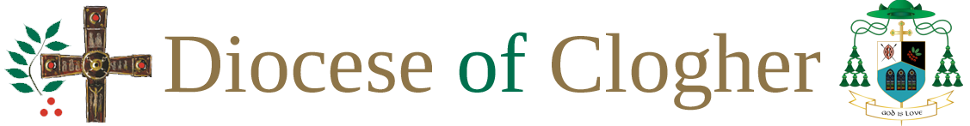

Media Permission Form
Data protection This form will be held on file in accordance with the data protection policy of (insert name of Church body). The data entered will be used only for the purpose indicated on this form. It may only be accessed by those who have responsibility for managing files or activities.
Child’s/young person’s consent:
I (insert first name and surname) would like to take part in (name of event) on (date of event).
(If relevant please tick the boxes below)
- I understand that photographs may be taken during the event, and I give my permission for these to be used in any hard copy/online (delete as appropriate) publications by the Church body.
- I understand that videos ( which may include webcam) may be taken during the event, and I give my permission for these to be used in any hard copy/online (delete as appropriate) publications by the Church body.
- I understand that updates may be posted on the Church body website and/or social network sites during the event, and I give my permission for my images/videos of me (delete as appropriate) to be used.
Parent/Carer’s Consent:
I agree to allow the above-named child/young person to attend this event during the period (insert start date and time) to (insert end date and time), in accordance with the permission granted by (insert name of child/young person).

Signed: _ _______________________ (Parent/Carer)
Name (block letters) _ _______________________
Relationship to child/young person _ _______________________
Signed _ _______________________ (Child/young person)

