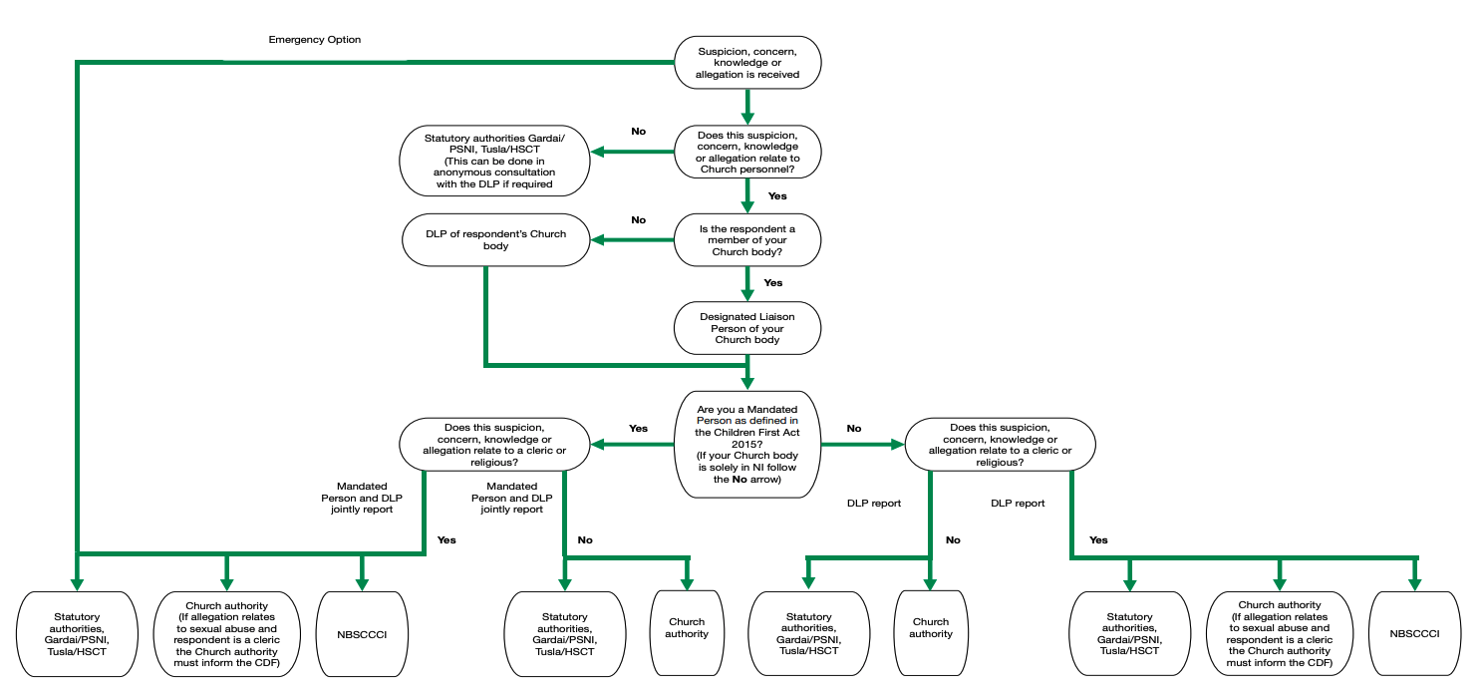
Flow Chart for Reporting Safeguarding Concerns

Designated Liaison Person (DLP):
Brendan Kelly: Tel.: 042 9741383 / 0044 86 4071397
Anne Molloy: Tel: 028 686 21158 / 0044 78 7941 3855
Martha Smyth: Tel: 028 66 324117 / 0044 777 550 7445

