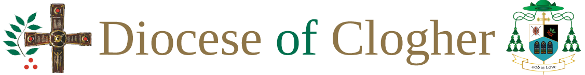

Code of Conduct for Young People
In order that young people will enjoy, benefit from and feel safe participating in church activities they will:
- be kind to each other and treat each other with respect regardless of ability ethnic origin, cultural background, sexual orientation or religion
- not engage in bullying type behaviour and will report any such behaviours if they become aware of it
- report any behaviour that makes them feel uncomfortable
- actively engage in the activity and contribute to the best of their ability in an age appropriate manner
- follow the instructions and directions of the activity leader
- arrive on time and depart at the appropriate time from the church activity
- remain in a supervised area at all times during the church activity
- not have in their possession any substances or material that may pose harm to any member of the group, the group leaders or the property in which the activity is held
- not take audio or visual recording of anyone present at the church activity (See guidance on photography and computer policy)
- keep mobile phones on silent or switched off during church activities
- respect the property of other people
- take care of their own property.

Information for Young People
If you have a concern or questions while you are taking part in a church activity, please contact one of the following:
Leader of Activity:
or
Parish Priest:
or
Parish Curate

Information for Parents/Carers
If you have a concern or questions regarding the safety and well-being of your child while he/she is involved in a church activity, please contact one of the following:
Leader of Activity:
Or
Parish Priest:
Or
Parish Curate:

If you have a concern about child abuse, please contact one of the following diocesan designated liaison persons:
Brendan Kelly, Tamlat, Castleblaney, Co Monaghan
Telephone: 042 9741383 Mobile :0044 86 4071397
Email: dlp1@clogherdiocese.ie

Anne Molloy, 10 Dunene Avenue, Kesh Road, Irvinestown, Co Fermanagh
Telephone: 028 686 21158 Mobile: 0044 78 7941 3855
Email: dlp2@clogherdiocese.ie

Martha Smyth, Raheen, 12 Hollyhill Road, Enniskillen, Co Fermanagh.
Telephone: 028 66324117 Mobile: 00447775507445
Email: safeguardingdirector@clogherdiocese.ie

