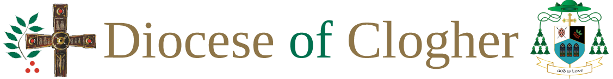

DIOCESE OF CLOGHER SAFEGUARDING CHECKLIST FOR PARISHES

It is essential to have the following in place in your parish to ensure best practice in Safeguarding.
1. Copies of Safeguarding Guidance for Parishes and Diocesan Adult Safeguarding Policy available in the parish.
2. Parish Safeguarding Representative(s) who have completed the Diocesan recruitment and selection process via the Diocesan Safeguarding Office as well as completing Safeguarding Training.
3. Safeguarding Poster with contact details of the Designated Liaison Persons, the Gardaí/PSNI and Tusla/HSC displayed in all church porches.
4. Recruitment procedure followed for everyone working with children and/or vulnerable adults.
5. Sacristy register to be signed by clergy, visiting clergy, sacristans, altar servers and their adult leaders. Eucharistic ministers and readers who process from the sacristy must also sign the register.
6. Garda/Access NI Vetting for everyone working with children and/or vulnerable adults.
7. Records of attendance for all children’s activities.
8. Parental consent forms for children taking part in Church activities.
9. Code of behaviour for children and adults.
10. Leaders, parents and children are aware of how to report allegations of abuse.
11. All forms are securely stored and in accordance with Data Protection guidelines.
12. Parish audits completed annually.
13. Provision of Towards Healing and Towards Peace posters

