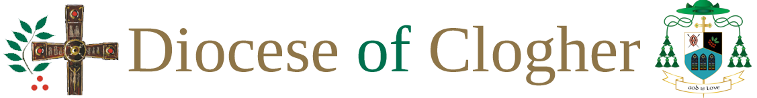

CELEBRET NOTICE

Any priest from outside the Diocese of Clogher who wishes
to participate as a celebrant or a concelebrant in a ceremony
in this church is required to provide the parish priest or his
representative with a valid celebret.

Bishop of Clogher:
Date:

